**1. What is the purpose of audience analysis in technical writing? How does understanding the audience shape the structure and content of technical documents?**

* The primary purpose of audience analysis in technical writing is to ensure that the information is communicated clearly and effectively to the intended readers.
* It should basically be tailor made for the reader - the language, tone, and style to their specific knowledge level, needs, and background. Their country of origin, age, background does matter. If they are a developer or user etc.
* It should address the audience's specific requirements, challenges, and their potential questions and solutions, their anticipated objections, and make the document more impactful.
* If not done -can cause misunderstandings and errors. We need to minimize the need for extensive rewrites and updates later in the writing process

**2. What are the primary skills you think one must have to become a good technical writer**

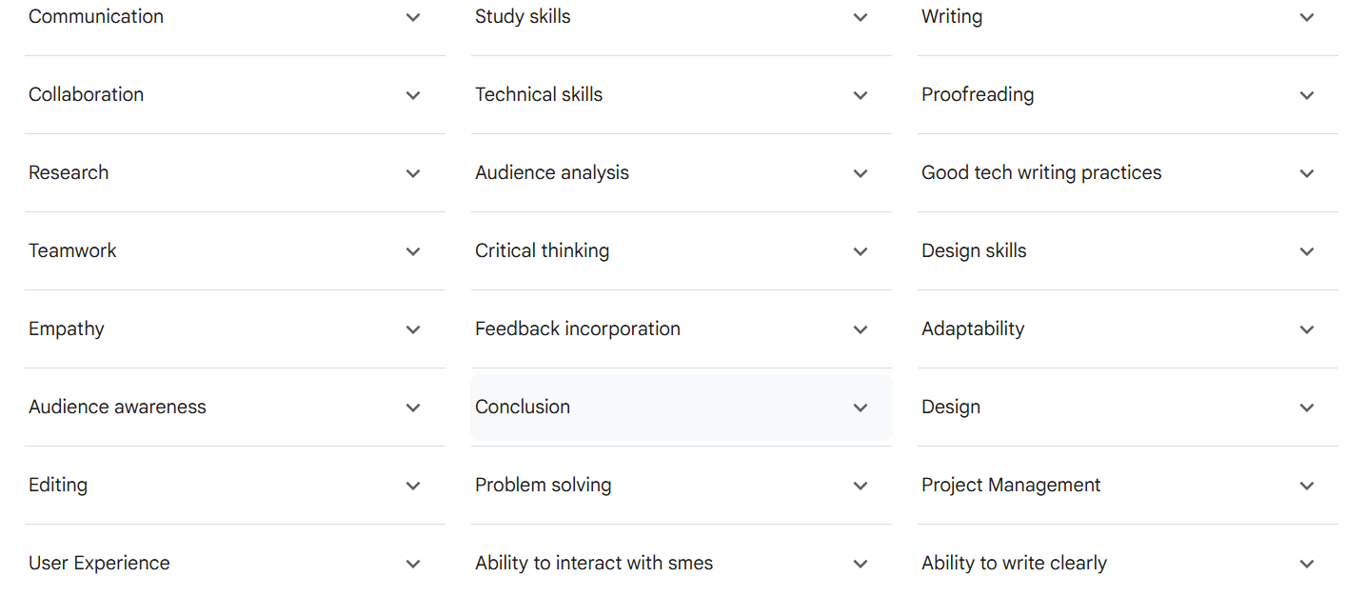

**3. Discuss the importance of visual elements (e.g., screenshots, diagrams, charts) in technical writing. How do they enhance the reader’s understanding of the content?**

* It says a picture speaks a thousand words. A diagram/screen shot can communicate a lot more than writing twenty lines.
* It simplifies complex information, improves the readers comprehension and retention ability. An image is remembered more in our minds than words.
* Makes a complex design more simpler to the user.
* Visual aids give a document a clear, organized structure, which helps readers find the information they need more quickly and efficiently.

**4. What are the key differences between a user guide and an API documentation?**

* User Guide:
  + Are typically for End-users, who are generally non-technical individuals using a product or software to accomplish a task.
  + Purpose: To explain how to use a product or software effectively, guiding users through features, functionalities, and workflows in a clear, non-technical manner.
  + Content Focus:Task-oriented instructions, step-by-step procedures, explanations of features in plain language, troubleshooting tips for common user issues, and information about the user interface
* API Documentation:
  + Developers, programmers, and other technical users who need to integrate with or build applications on top of an API.
  + Purpose:

To provide technical information and instructions necessary for developers to understand, integrate with, and utilize an API's functionalities.

* + Content Focus:

Detailed technical specifications of API endpoints, methods, parameters, data formats, authentication requirements, error codes, example requests and responses, SDKs, and code samples.

**5. What are the benefits of using simple language in technical writing, and how can you avoid jargon or overly complex terminology that might confuse the reader?**

* The intent of technical writing is to make the readers understand a certain content. It should be user friendly.
* Reduce mistakes, errors, misunderstandings.
* Reaches a wider audience.
* Better retention.

**6. What are the differences between structured and unstructured authoring? Which tools are best suited for each approach?**

Structured Writing

* A method of writing where content is created using specific components and a predefined structure, often enforced by a content model or markup language like XML.

Benefits:

Improved content consistency.

Efficient content reuse across different platforms.

Streamlined content updates and translations.

Faster production times and higher content quality.

Examples:

Creating technical manuals with specific, reusable topics, articles in a knowledge-based website, and content in XML.

* Unstructured Authoring

The creation of narrative-based documents with a free-flow structure, often using traditional word processing software without a specific content model.

Benefits:

Greater Flexibility: Allows for diverse formats and incorporation of information from various sources.

Natural Expression: Authors can focus on narrative flow and creative expression.

Drawbacks:

Lack of consistency

Limited reusability

Difficult to analyse.

Examples:

Documents created in standard word processors, PDFs, and PowerPoint presentations.

**7. What are the advantages of using cloud-based technical writing tools (such as Google Docs, Confluence, or Notion) for collaborative writing in teams?**

The advantages of cloud based technical writing tools is:

* Firstly, real time collaboration within the team, like multiple authors can work on a particular document as it is saved in one location.

Typically in a project, mails are sent back and forth for reviews and approvals

which can be avoided.

* Serves as a central knowledge base - all project related documents like training materials for onboarding new resources, process documents, knowledge sharing etc. Mostly for internal documentation purposes within the team.
* It is web based, we can access from anywhere and connect.
* Google drive, Confluence, Github are examples

**8. What is the role of templates in technical writing tools? How can using templates improve the efficiency and consistency of your documentation?**

* Templates provide a uniform and consistent design for your content. It is basically a design which is well organised, including font styles, headings, margins, and spacing.
* This is useful for any reoccurring document type like creating letters, reports, resumes.
* When a particular template is followed it allows the reader to find information easily and quickly.

A Word document template is a

* pre-formatted file that serves as a blueprint/design for new documents, containing pre-set formatting, styles, layouts, and content like headers and footers.
* By providing a standardized structure, templates save time and ensure consistency when creating multiple documents, such as business reports, resumes, or newsletters, allowing you to simply add your specific text and information to the pre-designed framework

Reuse existing template

Saves a lot of time

Quickly create document

Saves Time and Effort

: Templates provide ready-made structures and formatting, eliminating the need to start from scratch for every new document, which significantly speeds up the document creation process.

Ensures Consistency

: By using a template, all your documents will have a uniform look and feel, which is essential for maintaining brand identity, professional appearance, and standardized content.

Improves Accuracy and Reduces Errors

: Pre-defined content and formatting reduce the chance of mistakes, as less manual input is required for each document.

Enhances Professionalism

: Templates create a standardized and polished appearance for all documents, presenting a more professional image to clients and colleagues.

Simplifies Document Creation